

**APPLIED PHYSICS LAB**

**Lab Report: Determining the frequency of AC Current by Sonometer**

**Submitted To:**

Sir. Haseen Ullah Jan

**Submitted By:**

Ali Asghar

Section C

Registration No. 21PWCSE2059

Department Of Computer Systems Engineering

Fall 2021

**SONOMETER:**

A sonometer is an apparatus used to study the transverse vibrations of stretched strings. It is in the form of a hollow wooden rectangular box. On the wooden rectangular box there are two bridges and a pulley at one end.  A wire string is attached to one end of the wooden box, run over the bridges and pulley and carries a weight hanger at the free end.

**WORKING PRINCIPLE:**

A sonometer is used to determine the frequency of alternating current. A step down transformer is used for the determination of frequency of A.C. because the voltage of the A.C. mains is 220V, which is dangerous. The step down transformer reduces this voltage to 6 volts.The string wire of the sonometer is a non-magnetic metallic wire like brass or copper. A horse shoe magnet is placed at the middle of the sonometer wire so that the magnetic field is applied perpendicular to the sonometer wire in a horizontal plane.  
When an alternating current of definite frequency passes through the wire there will be interaction between the magnetic field and the current carrying conductor. So a force will act on the conductor in a direction perpendicular to both the field and the direction of current.

When A.C. is passing through the conductor, since the current direction reverses periodically, the direction of force also reverse periodically and hence, the conductor vibrates. Since the current flowing is alternating, the wire vibrates with a frequency equal to the frequency of A. C. By adjusting the length of the vibrating wire segment, this frequency can be made equal to the natural frequency of the wire segment. Then the resonance takes place and the wire vibrates with maximum amplitude. At this stage, the length of the wire segment is called the resonating length and it increases with increase in the mass of the suspended weights.

**FIGURE:**

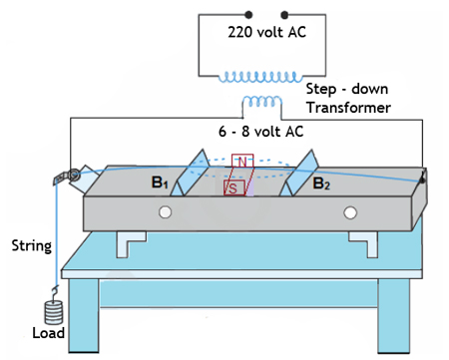

**APPARATUS:**

1. Sonometer
2. Weights
3. Step Down Transformer
4. AC main Supply
5. AC Ammeter
6. Rheostat
7. Wedges
8. Magnet

**PROCEDURE:**

1. I arranged the apparatus as shown in the ﬁgure below.
2. I switched the power supply on.
3. Then I started increasing the distance between the two wedges, L1 and L2 which are placed next to each other.
4. Then I placed the magnet in between the wire.
5. I set distance in such difference as to obtain maximum vibration in the wire.
6. I repeated this process by placing more weight in the pan.
7. At last, I took the readings from the procedure and wrote them down in the table given below.

**READINGS:**

|  |  |  |  |  |  |  |
| --- | --- | --- | --- | --- | --- | --- |
| S No. | m | L1 | L2 | L=L2-L1 | T=mg |  |
| 1 | 1000g | 4 cm | 49 cm | 45 cm | T=(1000)(980)  T=980,000 dyne | 48.24 Hz |
| 2 | 1500g | 4 cm | 58 cm | 54 cm | T=(1500)(980)  T=1,470,000 dyne | 49.23 Hz |
| 3 | 2000g | 4 cm | 68 cm | 64 cm | T=(2000)(980)  T=1,960,000 dyne | 47.96 Hz |
| 4 | 1250g | 4 cm | 52 cm | 48 cm | T=(1250)(980)  T=1,225,000 dyne | 50.55 Hz |
| 5 | 2500g | 4 cm | 75 cm | 71 cm | T=(2500)(980)  T=2,450,000 dyne | 48.33 Hz |

**AVERAGE READING:**

$$<f> =\frac{48.24 +49.23+47.96+50.55+48.33}{5}$$

$$<f> =48.862 Hz$$

**PRECAUTIONS:**

* 1. Protect yourself from Live AC wires.
  2. DO NOT DO THIS EXPERIMENT WITH 220 VOLTS directly.
  3. Do snug connections.
  4. Mark the readings where vibration of the sonometer wire is maximum.